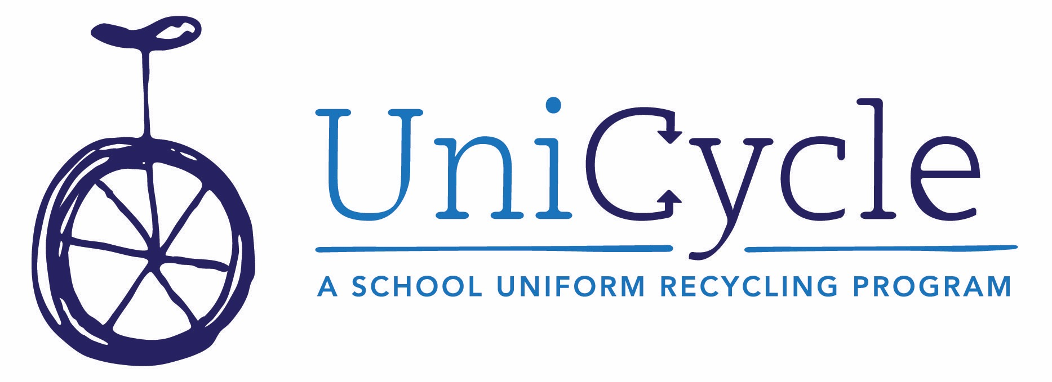
Below find several slightly different pieces of copy that can be used for a parent newsletter, email, or take-home folder note. One is written as if you’re just starting your UniCycle Closet; the other is geared toward schools who have launched the program but need to keep it top of mind to maintain donations. There’s a version of each for traditional SSA schools, and non-SSA schools. Please feel free to use them as they are, or to use as a starting point for edits and changes that make sense for your audience and needs. When posting on social media, remember to tag us on Facebook, Instagram and Twitter so that we can share your news!

Launch Copy for New UniCycle Partner School – Traditional Standard School Attire

Parents, we are excited to share that we’ve partnered with UniCycle, a local group that collects and distributes Standard School Attire (SSA) throughout all MNPS schools and the district’s Homeless Education Resource Office (HERO).

The program has about 75 school partners (and growing!). Here’s how it works: our school community will drop SSA items their children no longer need into the collection basket throughout the year, and those items will fill our UniCycle Closet for use by our students, then extras will go to UniCycle to be distributed to other school closets or directly to students in the HERO program. In turn, if our closet needs items that we haven’t collected, we request them from UniCycle and they’ll send what they have.

The UniCycle program is simple - they bring the practice of sharing “outgrown, not worn out” clothing from a family or neighborhood model to a school and citywide model. With Nashvillians acting as one big family, and with kids in a constant state of outgrowing their school clothes, we have more than enough polo shirts and khaki shorts to go around. UniCycle re-homed nearly 20,000 items of clothing last school year - let's jump in and make it work here!

UniCycle collects SSA in sizes 3T (for pre-K) all the way to adult, so feel free to add any items that fall under SSA guidelines, including your own polos and khakis!

Thank you for all your support, always!

Reminder/Refresher Copy for Current UniCycle Partner School – Traditional SSA

Parents, remember that we are a UniCycle partner school! What does this mean? Uniform + Recycle = UniCycle!

We have a collection laundry basket in the lobby, and we keep our emergency clothing closet filled up with donations of your students’ “outgrown, not worn out” school uniform items. Most of those too-small polos, khakis and all the rest are still in great shape to live a second life with another MNPS student. Once our closet is full, we send excess to UniCycle, where they distribute directly to students in the Homeless Education Resource Office program and to other school closets that need more than they collect. In turn, when our closet gets low or we have a special request for a student, we make a call to UniCycle, and they send it over. It’s a districtwide network that ensures that each student having access to school clothing that fits and “fits in” is possible with just a little organization and support from our MNPS families.

So, don’t forget to take a look through your students’ closets when you have time, and send in what they no longer need. It will be appreciated by another family! Collection is year round, and includes sizes 3T through adult (to fill closets from the pre-K to high school level). If you’d like to help with our school closet or propose a special project or collection drive (Girl or Boy Scout merit badge? Grade-level activity or challenge?) send a note to unicycle.nashville@gmail.com – they’d love to hear from you.

Thank you for your support, as always!

Launch Copy for New UniCycle Partner School – non-SSA

Parents, we are excited to share that we’ve partnered with UniCycle, a local group that collects and distributes school clothing throughout all MNPS schools and the district’s Homeless Education Resource Office (HERO).

The program has about 75 school partners (and growing!). Here’s how it works: our school community will drop school spirit wear and dress code-approved items their students no longer need into the collection basket throughout the year, and those items will fill our closet for use by our students, then extras will go to UniCycle to be distributed to other school closets or directly to students in the HERO program. In turn, if our closet needs items that we haven’t collected, we request them from UniCycle and they’ll send what they have.

The UniCycle program is simple - they bring the practice of sharing “outgrown, not worn out” clothing from a family or neighborhood model to a school and citywide model. With Nashvillians acting as one big family, and with kids in a constant state of outgrowing their school clothes, we have more than enough to go around. UniCycle re-homed nearly 20,000 items of clothing last school year - let's jump in and make it work here!

P.S. UniCycle is always in need of solid-color, polo-style shirts and khaki, black and navy bottoms – of every size - 3T (for pre-K) all the way to adult (for high schools), so feel free to add any items that fall under those guidelines and they’ll get them to schools with a more traditional dress code than ours!

Thank you for all your support, always!

Reminder/Refresher Copy for Current UniCycle Partner School- non-SSA

Parents, remember that we are a UniCycle partner school! What does this mean? We’re part of a districtwide network that collects and distributes school clothing through in-school closets and through the Homeless Education Resource Office.

We have a collection laundry basket in the lobby, and we keep our emergency clothing closet filled up with donations of your students’ “outgrown, not worn out” school clothing. Most of those too-small jeans and joggers and all the rest are still in great shape to live a second life with another MNPS student. Once our closet is full, we send excess to UniCycle, where they distribute directly to students in the Homeless Education Resource Office program and to other school closets that need more than they collect. In turn, when our closet gets low or we have a special request for a student, we make a call to UniCycle, and they send it over. It’s a districtwide network that ensures that each student having access to school clothing that fits and “fits in” is possible with just a little organization and support from our MNPS families.

So, don’t forget to take a look through your students’ closets when you have time, and send in what they no longer need. It will be appreciated by another family! Collection is year round, and the program always accept polo-style shirts and khaki, navy or black pants, shorts and shirts, even though our dress code is more relaxed. If you’d like to help with our school closet or propose a special project or collection drive (Scout merit badge? Grade-level activity or challenge?) send a note to unicycle.nashville@gmail.com – they’d love to hear from you.

Thank you for your support, as always!

