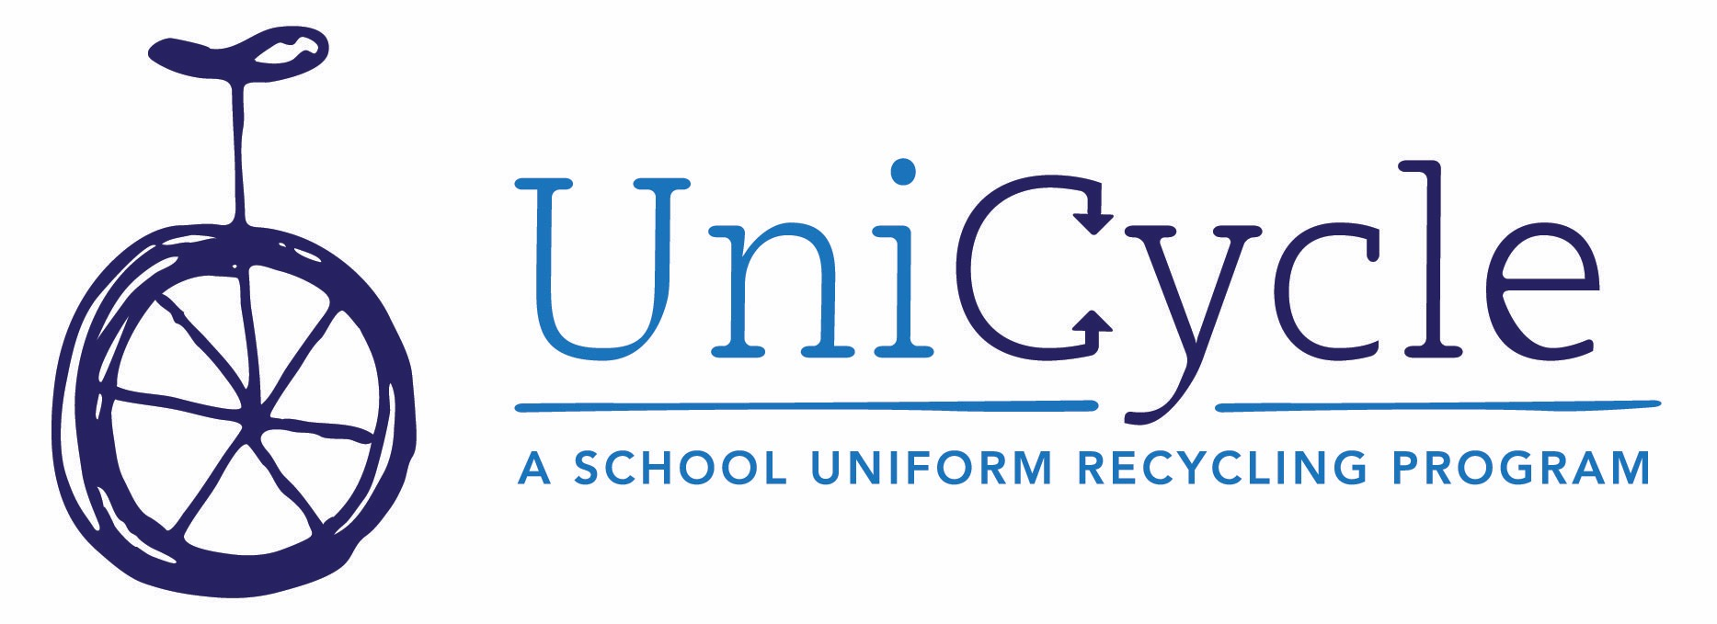
How UniCycle Works: A Guide for Teachers, Counselors,
Social Workers and School Staff

Uniform + Recycle = UniCycle

UniCycle is an independent, volunteer-run program that provides students in need with
Standard School Attire or otherwise appropriate school clothing.

WHERE DO THE CLOTHES COME FROM?

Parents at participating schools are encouraged to send in their kids’ “outgrown, not worn out” SSA (or dress code-appropriate items at non-SSA schools) and that clothing is collected in a UniCycle laundry basket placed in a central location. Once collected, your school’s UniCycle Coordinator sorts, cleans (if necessary), and fills your school’s closet with the clothing. If there is more clothing than your school needs, the extra goes to the UniCycle headquarters and is distributed to other schools that need more than they collect, as well as to students in the HERO program. In turn, your school can always contact the UniCycle headquarters to request items in specific sizes that you need to re-fill your closet or to give to a specific student.

HOW DO I GIVE ITEMS TO A STUDENT?

The beauty of the in-school UniCycle Closet is that there is no red tape involved. No rules. Use your judgment. If you see a student who looks like he or she needs a shirt, skirt, or pants—or a few of each—check your school’s closet for his or her size, and send them home with the student to keep. If you notice any students with an ongoing need, it’s always good to connect with your UniCycle Coordinator to see if something more can be done for the student or a specific request can be filled. It also makes sense to check whether or not the student is enrolled in the HERO program, if you suspect he or she may be underhoused and need additional services.

HOW ELSE CAN I HELP?

Spread the word to parents, friends, and other community groups who may be already supporting your school in other ways! With the UniCycle collection and redistribution system already in place and working so effectively, it’s easier than ever to donate school clothing to MNPS students, and potential supporters are more inclined to do so when they are assured their donations will quickly be put to use and worn by a child who needs new clothing. For the 2019/20 school year, UniCycle gave out approximately 20,000 before school closed in March.

Like and follow our Facebook page, Instagram and Twitter account to stay connected or email
unicycle.nashville@gmail.com.

