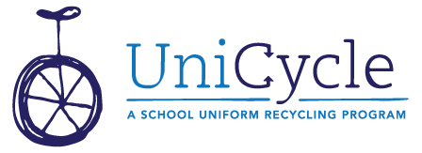
Dear Parents,
Our school has a UniCycle Closet (Uniform + Recycling = UniCycle!) that is open to every student. We collect “outgrown, not worn out” school clothing items in the collection laundry basket in the main office/lobby, and then we fill our school’s UniCycle Closet with lots of choices in each size for boys and girls. Any excess is sent to the UniCycle warehouse to be distributed to other schools whose closets need a re-fill.
These items were selected as they seemed to be a good fit for your child; please use them to round out his or her school wardrobe for the year, then you can pass them on to a sibling or return them to the UniCycle collection basket when they no longer fit. We’ll keep them in rotation until they truly get “worn out!” In this way, our school family is working like a real family to best use our resources, like outgrown school clothes! Please contact ______________________________________________ with any questions about the program. We’re glad you’re part of our school family!
------------------------------------------------------------------------------------------------------------------------------------------

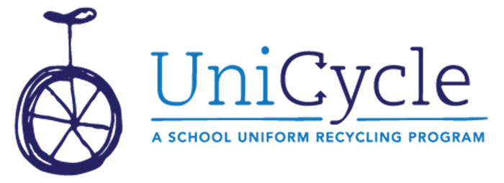
Dear Parents,
Our school has a UniCycle Closet (Uniform + Recycling = UniCycle!) that is open to every student. We collect “outgrown, not worn out” school clothing items in the collection laundry basket in the main office/lobby, and then we fill our school’s UniCycle Closet with lots of choices in each size for boys and girls. Any excess is sent to the UniCycle warehouse to be distributed to other schools whose closets need a re-fill.
These items were selected as they seemed to be a good fit for your child; please use them to round out his or her school wardrobe for the year, then you can pass them on to a sibling or return them to the UniCycle collection basket when they no longer fit. We’ll keep them in rotation until they truly get “worn out!” In this way, our school family is working like a real family to best use our resources, like outgrown school clothes! Please contact ______________________________________________ with any questions about the program. We’re glad you’re part of our school family!

